**Bug Report:**

Bug: Unable to get the Fibonacci number using the front end application.

Details: When the user enters the number in the box and clicks compute, the application fails to return the Fibonacci number. The screen stays the same.

Steps to recreate:

1. Copy and paste the link in any browser: <http://ec2-52-35-41-144.us-west-2.compute.amazonaws.com/>
2. Enter the number in the box
3. Click Compute

Screenshot below:

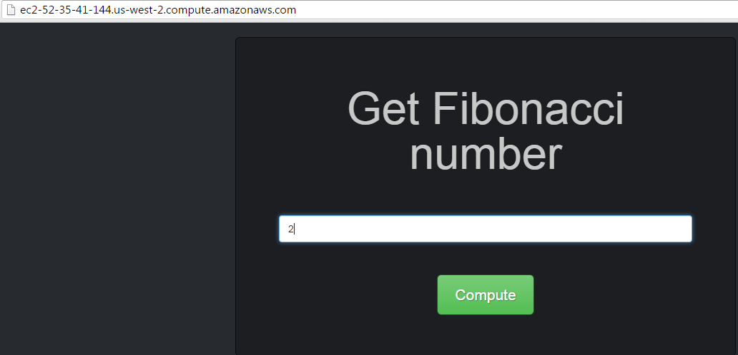

Error Trace using developer tool:

